CPSC 359 Assignment 1

Name: Ayman Shahriar

UCID: 10180260

1) Problem to solve:
We have to design a combinational logic circuit that takes a 4 bit number as input (from 0000 to 1111) and produce a unique 3x3 LED pattern as output.
Here are the following 16 display patterns corresponding to the input bit patterns
0000, 0001, 0010 … 1111:

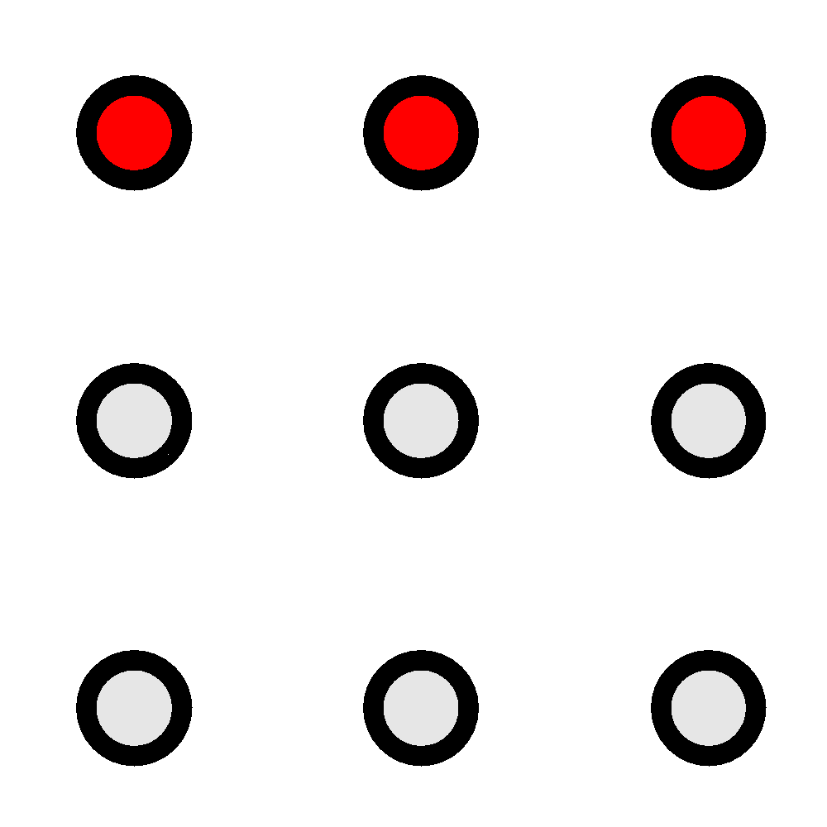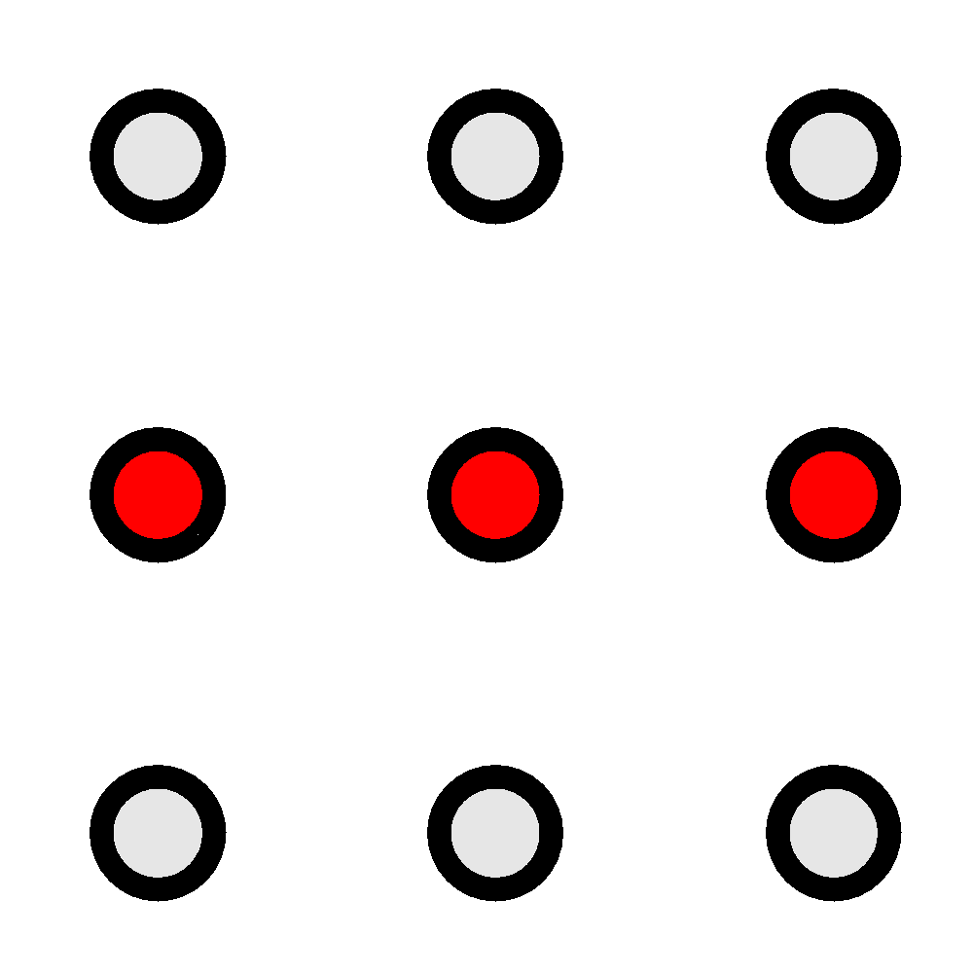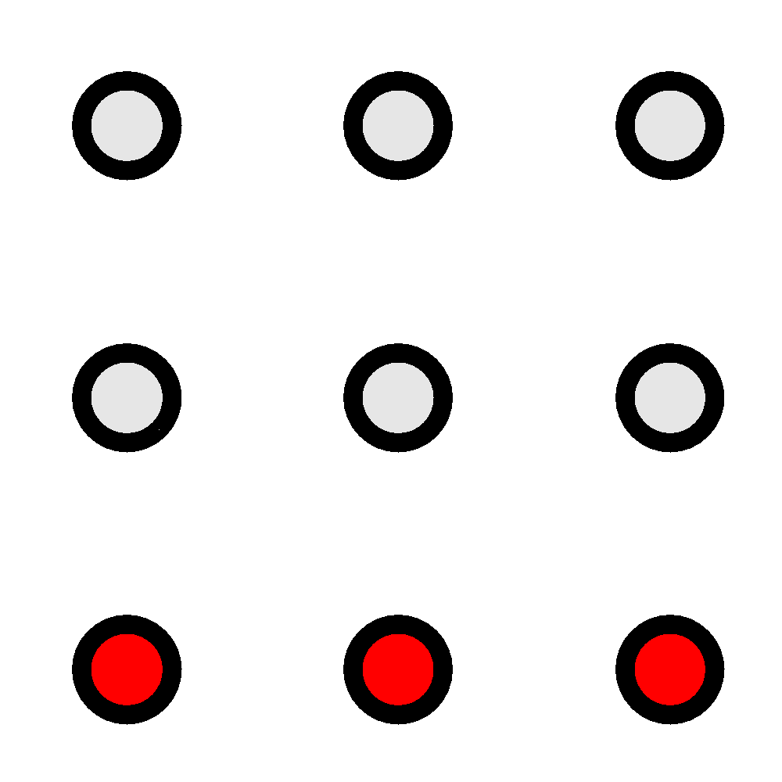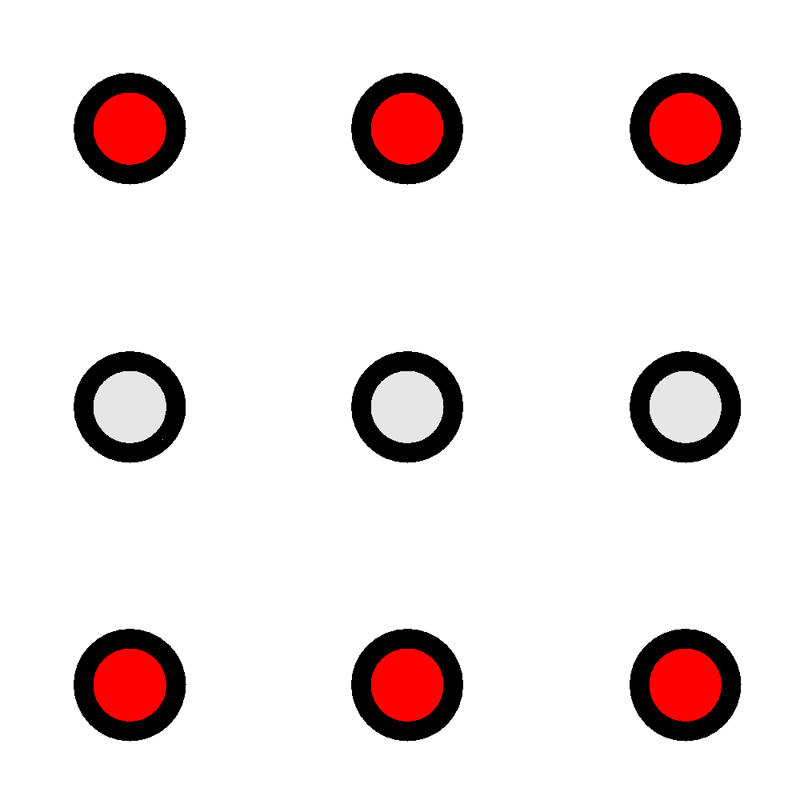

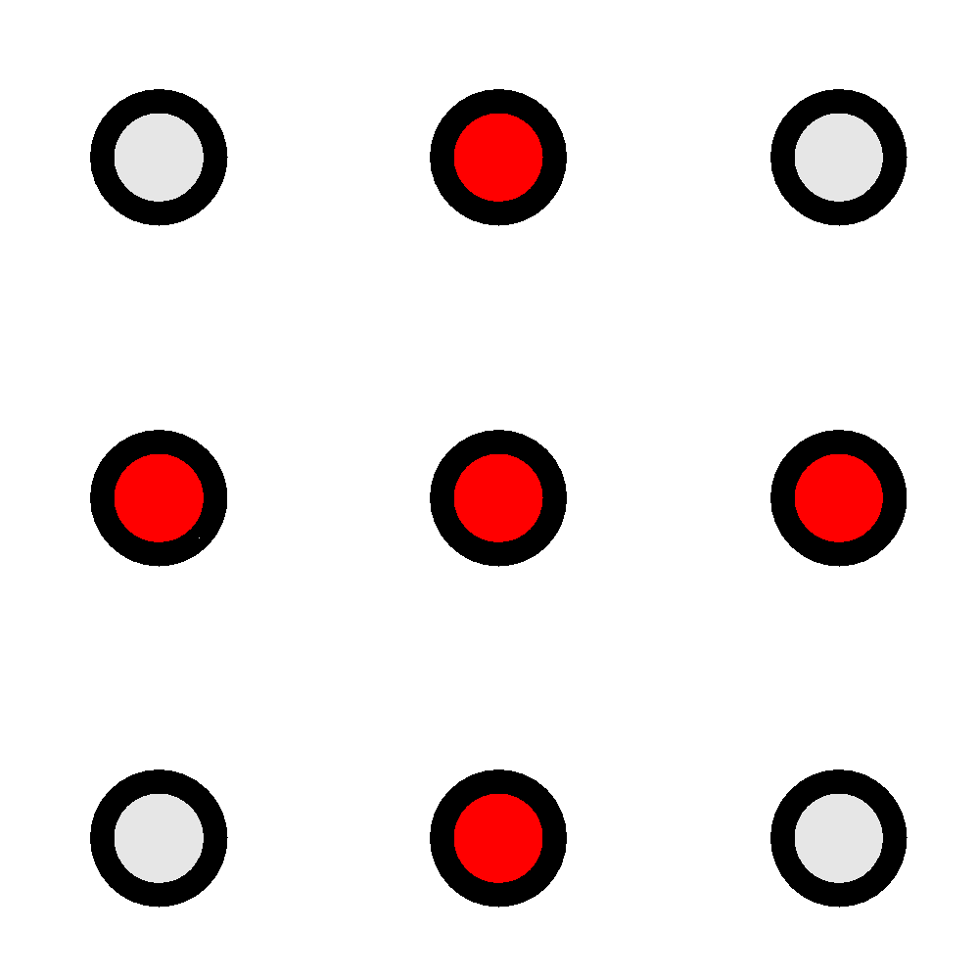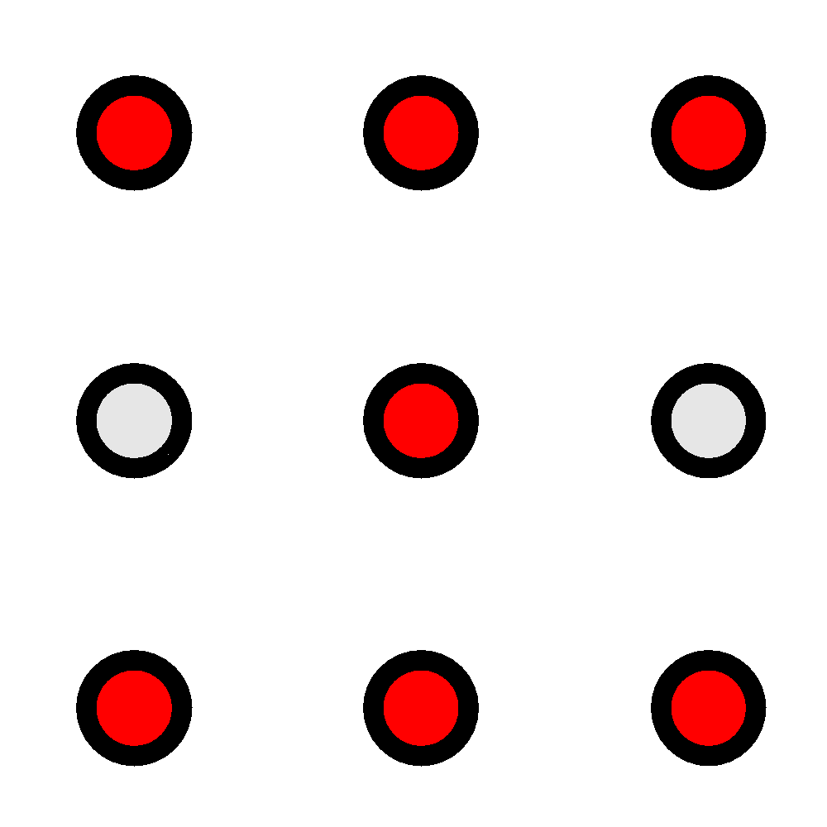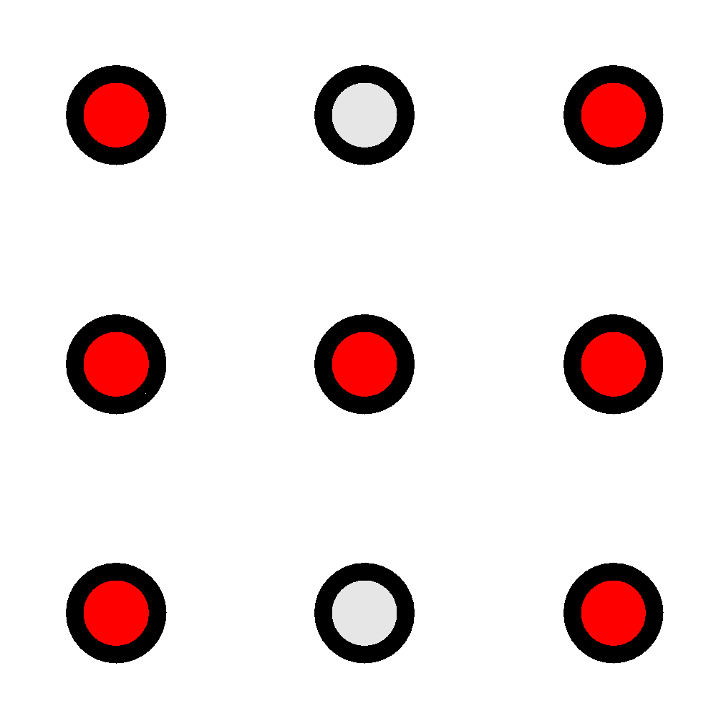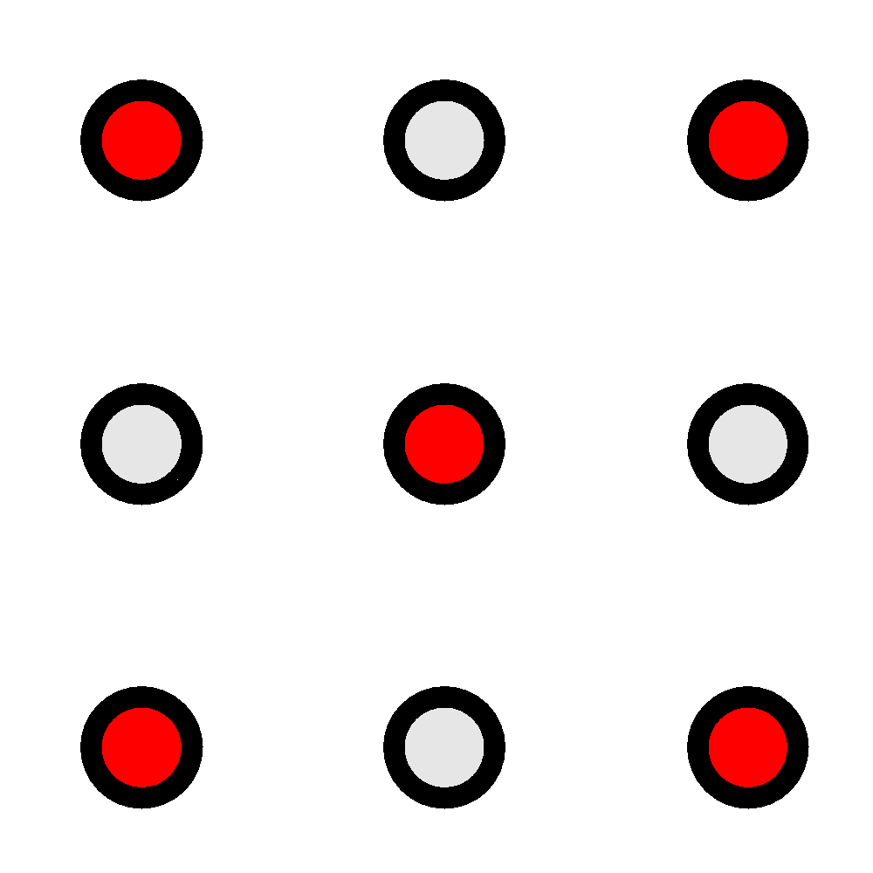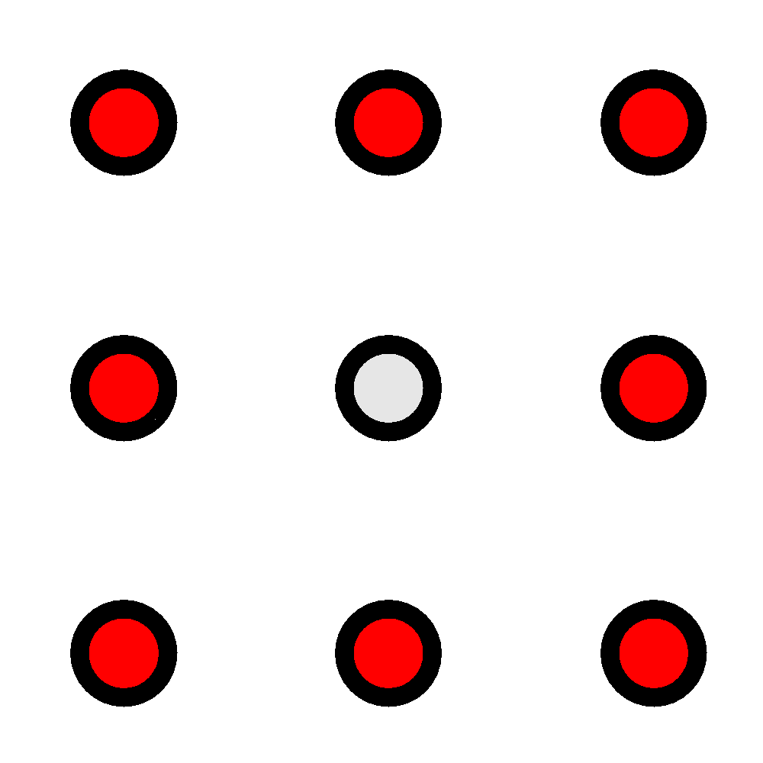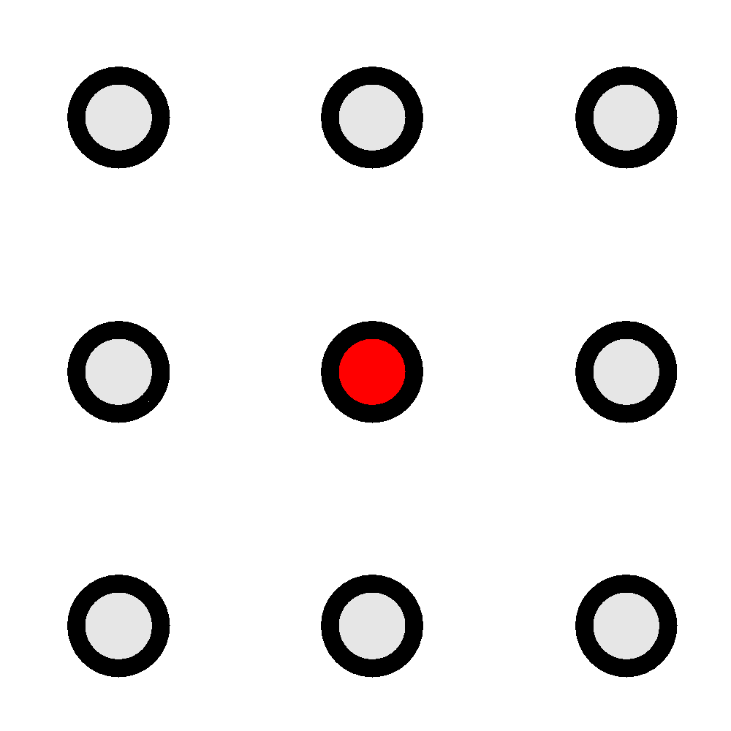

The arrangement and labelling of the LED’s are shown below:
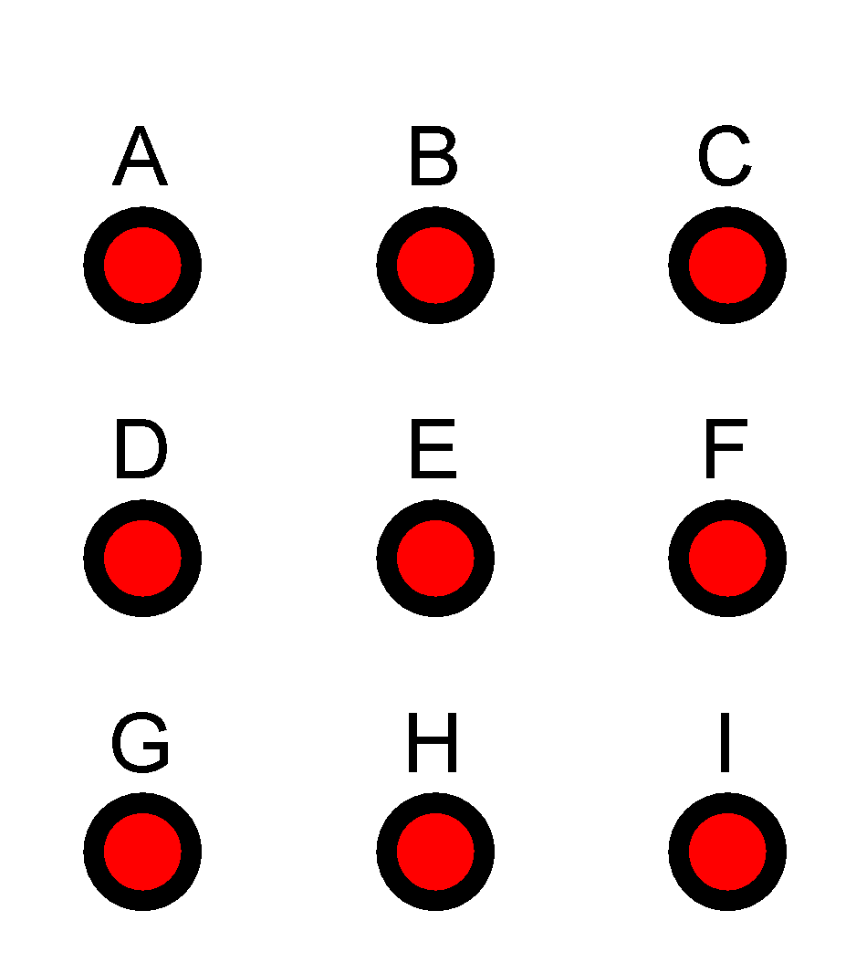

2 & 3) Determining the input and output variables, and assigning letter symbols to the variables:
There are four input variables:
- z: the “ones”
- y: the “twos”
- x: the “fours”
- w: the “eights”
There are 9 output variables, each corresponding to an LED output:
- A, B, C, D, E, F, G, H, I

4) The truth table defining the relationship between the inputs and outputs is on page 3.
5) The simplified function for each output, as well as all the steps needed to obtain them, are in pages 4 - 6.
6) The logic diagrams for each output function are in pages 7 - 11.

